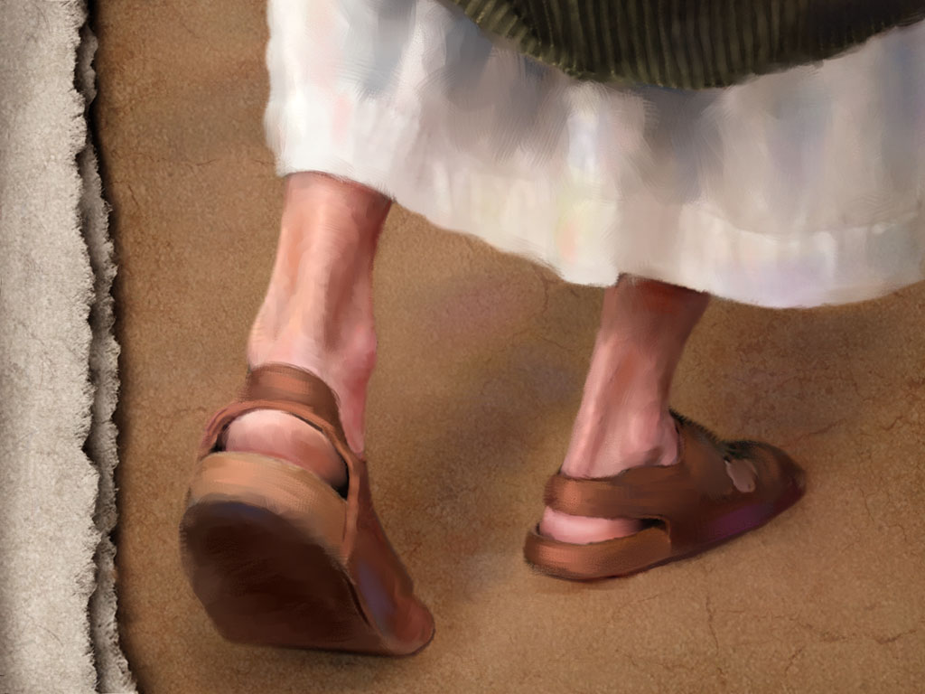
May 22, 2011
When God Chose Sandals:

No Gain, No Pain - Mark 3:20-35

2 Stories = 1 Story

20-21:

22:

23-30:

31-35:

1. We will be ____________ by Satan when we are making a _______________ for Christ. (20-22)

- Opposition can come from ______________________ (20-21)

- Opposition can come from _________________ attacks (22).

Two charges:

1.

2.

Discipline?

2. When we do __________________, it is His ____________ (23-30)

3 step response:
1.

2.

3.

A. _____________ the work of and live by the _____________ the Holy Spirit. (23-30)

Blasphemy of the Holy Spirit:

B. ____________ together with fellow soldiers who care most about _______________________. (31-35)

Equipping – Memorization:
John 16:13 When the Spirit of truth comes, he will guide you into all the truth, for he will not speak on his own authority, but whatever he hears he will speak, and he will declare to you the things that are to come.

