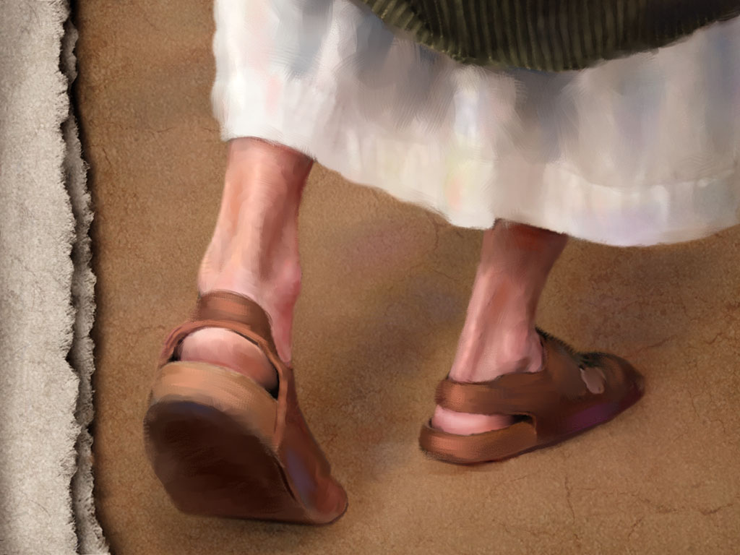
May 29, 2011
When God Chose Sandals:

Have You Cultivated the Dirt This Morning? - Mark 4:1-20

Setting the scene: (1-2)

Hear the Parable: (3-9)

Why Parables? (10-12)
1. _________ and ___________ genuineness.

- ________________

- To ______________ use man’s _____________ or ______________ for God’s purposes.

2 Principles for understanding parables!
1. ______________ spiritual assimilation –

2. ______________ spiritual atrophy -
Our receptivity to God’s Word directly affects its fruit in our lives and in the lives of others. (13-20)


1. The ____________ heart (15)

2. The ____________ heart (16-17)

3. The ____________ heart (18-19)


4. The ____________ heart (20)

How do I cultivate my soil to be ready to receive God’s Word?

Equipping – Memorization:
Mark 4:20 But those that were sown on the good soil are the ones who hear the word and accept it and bear fruit, thirtyfold and sixtyfold and a hundredfold.

