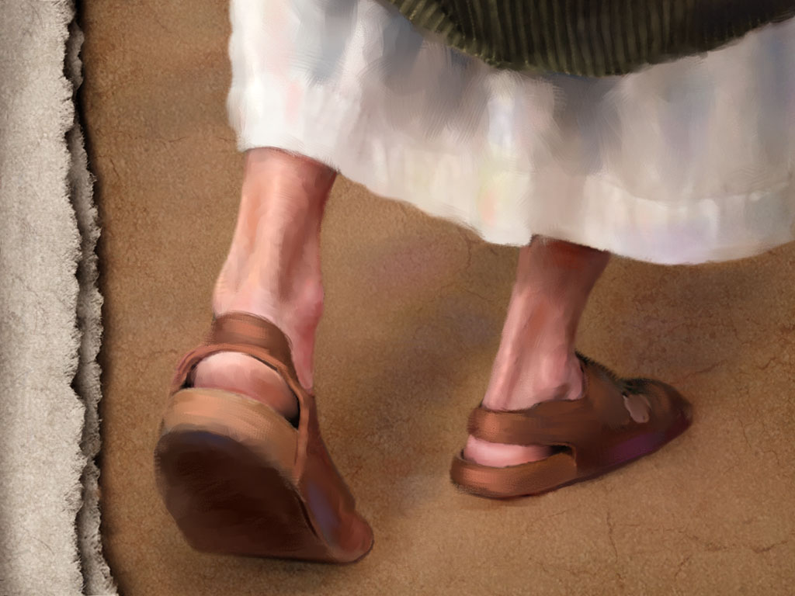
June 12, 2011
When God Chose Sandals:

Is Your God Too Small? - Mark 4:35-5:20

Expanding our understanding of the Servant Savior:

1. Jesus is ___________ over every ____________ we face. Trust Him. (35-41)

The challenge:

Jesus’ response:

The result:

3 lessons from the calming of the storm:
A. God often ______________ allows storms in our lives to _________ and ____________ our faith. We need to be open to it.

- We struggle with ___________ when we have _________________ of God.

- Storms bring us into a ____________________ of God . . . if we are receptive!

2. Jesus has dominant authority over _______ and ____________. Rely on Him (35-41)

The challenge:

Jesus’ response:

The result:

3 lessons from the healing of the demoniac:
A. We cannot overcome sin and Satan without __________________

- The ______________ of Christ’s power over sin and Satan is _________________.

- We can experience God’s ___________ over sin . . . if we are willing to ______________.

Equipping – Memorization:
Mark 4:40-41 He said to them, “Why are you so afraid? Have you still no faith?” And they were filled with great fear and said to one another, “Who then is this, that even the wind and the sea obey him?”

