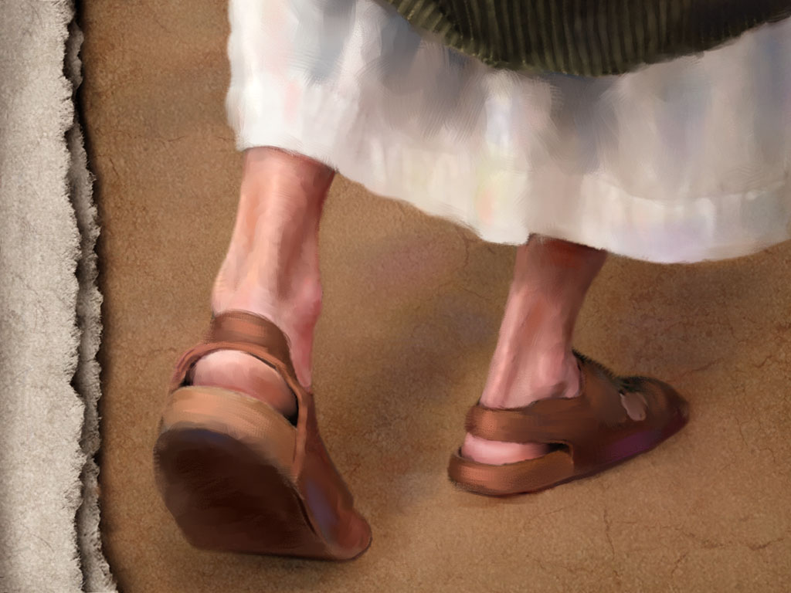
June 19, 2011
When God Chose Sandals:

More than One Dad

The example of Jesus:

9 Qualities of a spiritual father:

Paul and Timothy:
1. Spiritual fathers see those they invest in as their ______________
1 Tim 1:2

Honor Point: _____________________

2. Spiritual fathers ___________________ the ones they disciple.
2 Tim 1:2

Honor Point: _____________________

3. Spiritual fathers will ____________________ for you. 2 Tim 1:3

Honor Point: _____________________

4. Spiritual fathers _______________ their children in the faith.
1 Tim 1:18-19

Honor Point: _____________________

5. Spiritual fathers _________________ with those they disciple.
Phil 2:22

Honor Point: _____________________

6. Spiritual fathers want their children to pass on the faith to others.
2 Tim 2:1-2

Honor Point: _____________________

Paul and Titus:
7. Spiritual fatherhood comes from _________________. Titus 1:4

Honor Point: _____________________

Paul and Onesimus:
8. Spiritual fathers ____________________________ for their spiritual children. Philemon 8-19

Honor Point: _____________________

Peter and Mark:
9. Spiritual fathers may never see _______________________, but they invest anyway. 1 Pet 5:13

Honor Point: _____________________

