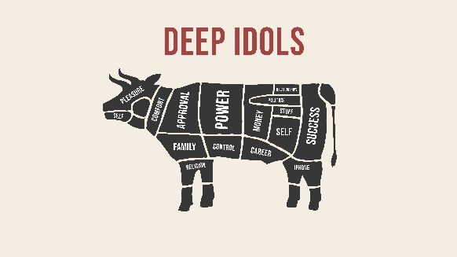
The Sin Beneath the Sin

May 16, 2021

What is an idol?

An idol is anything that takes the place of God as ultimate in our worship, love, and lives

The Lure and Lies of Idols:
(Eccl 3:11, 12:13; Rom 1:25; Gen 29:31-35, 30:1-2, 7-8)

Removing idols – How do we get rid of them?

- We cannot remove idols – we can only replace them

- Speak God’s truth to yourself of the _____________, stupidity, and damage idols cause

- Idols control and _____________ by opening the door for all kinds of evil (Rom 1:22-31; Col 3:5)

- Idols ______________ our thinking and feelings (Jonah 4:1-9)

- Idols _______________ us from God (Ezekiel 14:4-8)

- Idols ________________ other lives around us
- ______________ your idols and confess (1 John 1:9; Matt 6:21)

  - Where do your thoughts go when nothing is demanding your attention?
  - What do you worry about most?
  - What do you spend your money and time on most effortlessly?
  - Where do you have uncontrollable emotions like anger?
  - What unanswered prayer or frustrated hope has embittered you toward God or made you question your faith or trust?
  - What do those closest to you say?
  - What do you use to comfort yourself when things go bad or get difficult or to feel better?
  - What makes me feel the most self-worth?
  - Early on, what do you want to make sure people know about you?
  - What would really make you happy?

- Ask God to _______________ your desires for your idol with a highest love for and trust in Him (Col 3:1-4)

Surface idols:

Deep idols:


Equipping – Memorization:
Col 3:1-2 If then you have been raised with Christ, seek the things that are above, where Christ is, seated at the right hand of God. Set your minds on things that are above, not on things that are on earth.
The Sin Beneath the Sin

May 16, 2021

What is an idol?

An idol is anything that takes the place of God as ultimate in our worship, love, and lives

The Lure and Lies of Idols:
(Eccl 3:11, 12:13; Rom 1:25; Gen 29:31-35, 30:1-2, 7-8)

Removing idols – How do we get rid of them?

- We cannot remove idols – we can only replace them

- Speak God’s truth to yourself of the _____________, stupidity, and damage idols cause

- Idols control and _____________ by opening the door for all kinds of evil (Rom 1:22-31; Col 3:5)

- Idols ______________ our thinking and feelings (Jonah 4:1-9)

- Idols _______________ us from God (Ezekiel 14:4-8)

- Idols ________________ other lives around us
- ______________ your idols and confess (1 John 1:9; Matt 6:21)

  - Where do your thoughts go when nothing is demanding your attention?
  - What do you worry about most?
  - What do you spend your money and time on most effortlessly?
  - Where do you have uncontrollable emotions like anger?
  - What unanswered prayer or frustrated hope has embittered you toward God or made you question your faith or trust?
  - What do those closest to you say?
  - What do you use to comfort yourself when things go bad or get difficult or to feel better?
  - What makes me feel the most self-worth?
  - Early on, what do you want to make sure people know about you?
  - What would really make you happy?

- Ask God to _______________ your desires for your idol with a highest love for and trust in Him (Col 3:1-4)

Surface idols:

Deep idols:

Equipping – Memorization:
Col 3:1-2 If then you have been raised with Christ, seek the things that are above, where Christ is, seated at the right hand of God. Set your minds on things that are above, not on things that are on earth.

